**China: The fall and rise of Chinese futures,1990-2005**  
http://www.futuresindustry.org/images/clear.gif

*by Wang xue Qin and Nick Ronalds*

There is an increasing consensus within the futures industry that this decade will see the rise of the Asian futures markets to world prominence. This potential rise first came into view in the early 1990s. In the first few years after the introduction of commodity markets, new exchanges opened with wild abandon, and speculative volume ballooned.

Unfortunately the frenzied growth of China’s futures markets was accompanied by rampant abuse, triggering two waves of reform, the “First Rectification” and the “Second Rectification.” The First Rectification was launched with the publication of a directive informatively titled The Notice of Firmly Curbing the Blind Development of the Futures Market. Over the subsequent five years, authorities slashed the number of exchanges from over 40 to 15, delisted 20 futures contracts (leaving 35), began issuing licenses to futures commission merchants for the first time while lopping their number by over 70%, restricted trading on foreign futures exchanges, introduced new rules and regulations, and shifted the control of the exchanges from local governments to regulatory authorities.

Continued abuses following the First Rectification, however, led to the “Second Rectification” in 1998, another dose of the same medicine. Eleven of the 14 exchanges that survived the first round were shuttered, bringing the number down to today’s three: The Shanghai Futures Exchange, the Dalian Commodity Exchange, and the China Zhengzhou Commodity Exchange. The number of futures contracts was cut back further to 12 from 35, and more brokers were closed, leaving just 175 standing from the early 1990s peak of 1,000. Margins were standardized and regulations further toughened. Trading on foreign futures exchanges was further restricted to a small number of large, global entities. (See “The Short, Dramatic History of Futures Markets in China,” Journal of Global Financial Markets, Spring 2002, by Wang Xue Qin and Michael Gorham.)

The China Securities Regulatory Commission, formed in 1992 to clean up the securities industry, was given authority over the futures industry with a similar mandate during the first rectification in 1993. Its current chairman was formerly the chairman of the China Bank of Agriculture. He reports to the State Council, China’s highest executive and administrative body.

Volume, as measured by the notional value of trading, exploded from half a trillion RMB in the first year of futures trading in 1993 to 10 trillion only two years later. At that point the first and second rectifications took their toll on volume, which declined steadily to 1.6 trillion in 2000.

This decade has seen a very healthy revival, with volumes reaching an all-time high last year of 14.7 trillion RMB. The Dalian Commodity Exchange traded 177 million contracts, 58% of the country’s total. The Shanghai Futures Exchange followed with 77 million (26%), and the China Zhengzhou Commodity Exchange logged 50 million contracts, 16% of the total. On a notional value basis, the SHFE leads with a share of 57%, followed by the DCE (35%), and the CZCE (8%).

By contract volume, soybeans lead with 38% of 2004 volume. Copper is next with 14%, followed by soy meal futures (16%), wheat (14%), cotton (8%), and aluminum (4%). Looking at volumes on a notional value basis, the chief difference is that copper, with its larger contract size than the agricultural commodities, takes a commanding lead with 39% of the total notional value.

The composition of the volume is a somwhat sensitive question in China, and no public records or official research document its breakdown. Anecdotal information suggests that the speculative volume is still high, but lower than the boom years of the 1990s and probably falling as more hedgers enter the market.

**Organization of Chinese Exchanges**

A would-be exchange’s first challenge is to get approved by the CSRC. Since most of exchanges operating in China during the 90s were shuttered during the two rectifications, approval was a prerequisite to survival. An exchange approved by the CSRC must also register with the State Administration of Industry and Commerce, a high-level government body with broad regulatory responsibilities. An exchange is expected to have minimum capital of some 100 million Yuan, around $12 million, contributed in equal amounts by all members, with the total amount depending on the size of membership. Once approved, an exchange has a license to operate for 50 years, a horizon distant enough not to have raised questions yet about what happens when the half-century mark is reached. Today’s post-rectification Chinese futures exchanges are financially independent of any government body. On the one hand, that means they have to make do without the public subsidies of the hyper-competitive pre-rectification days (in fact they had to pay back investments made by the local governments), but on the other hand rising volumes and the more rationalized industry structure has kept revenues quite healthy.

Exchange rules provide that the governing body of each exchange is the “Members Congress,” presided over by a chairman and general manager appointed by the CSRC (following their appointments, they are expected to be “ratified” by an election of the membership). A quorum consists of two-thirds of the members, with decisions requiring a majority of members present. The Members Congress approves all new rules and initiatives, oversees staff, approves budgets, etc. A board of directors (sometimes translated as “council of governors”) is made up of nine directors selected by vote from the exchange membership, and six from outside.

The board oversees the committees that encompass the various functions of the exchange—audit, trading, delivery, membership, dispute resolution, finance, technology, etc. These committees are composed of staff of the exchange itself, staff of member companies, as well as recognized experts from academia or elsewhere.

Clearing departments within each exchange both clear and guarantee trades for members. Margins are specified in the exchange rulebooks as 5% of contract value for most products, though the levels are raised as a contract moves closer to delivery. The exchanges determine the margin levels subject to CSRC approval. The intra-day limit move, incidentally, is 3% of contract value.

A key inter-exchange initiative this year is a systems upgrade aimed at greatly enhancing the ability of exchanges and regulators to monitor members’ compliance with rules on segregation and use of client monies. The upgrade will reduce the reporting lag to one day from one month, and is regarded by the regulators as one of the prerequisites for the introduction of new products, especially options.

**Who Are the Members?**

Only companies, not individuals, can be exchange members. To get approved, an applicant has to:

* Be a registered company within the People’s Republic of China;
* Have the financial wherewithal consistent with its business purpose;
* Be of good reputation, which includes having no record of serious rule violation on any exchange over the prior three years;
* Have a strong management team and organizational structure as well as staff knowledgeable about futures;
* Have acceptable financial and operational risk management systems in place;
* Obtain a brokerage license if the member intends to engage in brokerage; and
* Meet “other conditions which the regulator and the exchange stipulate.”

The last criterion obviously gives the CSRC and the exchange latitude for a discretion they feel they need in what is a relatively immature industry.

The criteria above are the official ones. What is the reality? China has been going through a grueling bear market, and it’s no secret that the financial industry is not in good shape. To address the marginal quality of some smaller Chinese FCMs, the CSRC in January imposed a requirement that the Settlement Reserve, a contingency fund, be increased for every member firm from 500,000 Yuan ($60,000) to four times that. Several FCMs were forced out of the marketplace as a result.

The CSRC set an objective criterion and four “soft” criteria in deciding whether to approve a new FCM. The objective one is a minimum capital requirement of 30 million Yuan, equivalent to about $3.7 million. The firm’s staff must have experience with futures, an easier requirement than one might think given the futures boom of the 1990s. The firm must have a bona fide place of business and the infrastructure to provide brokerage services. The latter would include electronic trading systems, exchange connectivity, and so on. The CSRC also says it looks for “sound” management. Since the second rectification, an absolute prohibition on proprietary trading by brokers has been in effect.

In practice, however, the experience has been that the regulators are focused on winnowing a population that was wildly excessive from the start, and getting a new license approved today would be a challenge to say the least.

Even though the Chinese exchanges are all-electronic, they continue to have trading floors. These trading floors are staffed by FCM employees who receive orders by phone and enter them on their terminals. This “floor” volume accounts for some 40% of the total. The other 60% is generated by internet orders originating from branch offices of the member firms, which includes customers trading directly on branch office terminals.

**New Products**

By the early part of this decade, the surging Chinese economy was gobbling up a rapidly growing share of the world’s raw materials. All this added demand put heat under both prices and volatility. The need for more risk management tools became increasingly evident. Economics alone, however, wouldn’t have sufficed to make regulators open to new futures products if the futures markets hadn’t also been well behaved since the reforms of the second rectification. Better exchange management, more effective regulation, and the taming of the abuses of the go-go days gave the regulators courage. In 2004 new contracts were approved for the first time since the industry’s tumultuous beginning. To keep things fair, each exchange got something: the SHFE was allowed to list fuel oil futures, DCE corn, and CZCE cotton.

In theory, a new contract can be listed upon approval by the CSRC. In practice, the CSRC won’t approve a product unless a consensus has been formed by the State Council and almost any ministry or commission that has some interest in the product. For some products that means over 10 ministries and commissions have to weigh in before a new contract gets a green light.

Another aspect of the approval process that makes for cautious approval, if one were needed, is that regulators and others with some tie to the product demand from the exchanges a virtual guarantee of success. Unlike the western system where the exchanges are free to fail or look foolish, failure could mean loss of face and career risk for too many parties in China’s hybrid system.

Products in the pipeline or under research include:

* SHFE: options on copper futures, futures on steel, zinc, gasoline, diesel oil, coal and stock indices;
* DCE: options on soybean futures, futures on soybean oil, steel, government bonds and commodity indices;
* CZCE: options on wheat and cotton futures, futures on refined sugar, canola, rice, fertilizer, coal, electricity and government bonds.

Where several exchanges are working on the same product, e.g., bonds, coal and steel, which one gets to list? The answer will be determined not by slugging it out in the market but by persuading the regulators of the superiority of the exchange’s research, the greater fairness and appropriateness of the product trading at that exchange, and other relatively subjective considerations.

**Options and the CAO Disaster**

All three exchanges are laboring mightily to introduce options. Volatility and the need for hedging tools notwithstanding, it’s not a slam dunk to get it done this year. In the higher reaches of government, options are viewed as a “derivative.” This wariness no doubt was strengthened by the spectacular $550 million losses of China Aviation Oil last year from selling OTC crude oil calls.

On the other hand, the Futures Daily published an article by Tian Yuan, the chairman of the China Futures Association, making the point that concealing the losses that led CAO to the brink would have been virtually impossible if the trader had been using exchange-traded options. This point undoubtedly has been absorbed at least by those in China with some understanding of derivative markets. But as any reader of Futures Industry knows, “derivatives” are irresistible scapegoats even in developed markets, and cautious regulators know this better than anybody.

The upshot is that a number of things need to go right for option contracts to see the light of day in China this year: an economy on solid footing, continued steady volume in the existing futures contracts with no newsworthy trading abuses, and no more derivative-tainted financial disasters, on or off exchange.

All three exchanges have developed contract specifications and economic justifications for introducing options—soybean options in the case of DCE, copper options for the SHFE, and both cotton and wheat options for the CZCE. The exchanges are, however, at various stages of completing the necessary enhancements to their clearing systems to accommodate options. In addition, brokers and customers need to be brought well up on the learning curve, especially given that the success of a new product launch is supposed to be a sure thing. Consequently it is possible that the introduction of options could be pushed into late this year or even next year.

As an aside, an interesting debate is taking place as to what commodity should be the underlying for the first option contract. Some argue that it should be on a relatively stable commodity, such as wheat, in which case it is least likely to be disruptive to the market. Others argue that it should be on a volatile commodity, such as soybeans, in which case it is more likely to meet demand.

**Financial Futures**

The other eagerly awaited product class is financial futures, and some hopeful auguries are in the wind. This year’s agenda is filled with conferences, seminars, and studies on financial futures and options organized by the exchanges, the China Futures Association, and third parties.

Chicago Mercantile Exchange signed an MOU last year with the China Foreign Exchange Trading System & National Interbank Funding Center to work toward the establishment of foreign currency derivatives in China. CFETS is a sub-agency of the central bank and is the only source of supply in China for foreign currency. Another positive sign for financials was the decision by the Chinese authorities earlier this year to select seven foreign and two domestic banks as market makers in eight new currency pairs sometime in the second quarter of this year. Xinhua, the Chinese news agency, said the move is aimed at increasing the efficiency of the Chinese FX market and to prepare the market for eventual full convertibility.

Stock index futures are also under active discussion. In April the Shanghai Stock Exchange and the Shenzhen Stock Exchange announced the creation of the Unified Stock Index, a 300-share index that represents companies listed on both exchanges. Insiders quietly admit that the eventual launch of a futures contract was one motive for its development, but saying so openly at this point would be presumptuous.

For one thing, the massive overhang of company stocks owned by the state, estimated at between 70%-80% of total capitalization, is viewed as a problem that needs fixing first. As of early May, the capitalization-weighted Shanghai Stock Price Index was down some 48% from its June 2001 peak. This reflects in part the market’s expectation that the state-owned shares will inevitably be sold sooner or later. Another obstacle to a stock index contract is the current prohibition on short selling, though stock indexes have succeeded elsewhere despite constraints on short selling (e.g., Japan in the 80s and 90s, not to mention the U.S. and the uptick rule).

In the meantime, the Shanghai Futures Exchange and the Shanghai Stock Exchange have been researching stock indexes. Which exchange, the futures exchange or stock exchange, will list the product when the time comes is an open question.

In short, financial futures such as bond or stock index futures will likely have to wait their turn. Once options have made a successful debut, the regulators and the industry will look toward the new products with greater confidence and openness, and the prospects for financial products will look up.

Another wildcard, however, is the economy. A hard landing for the Chinese economy this year or next and innovation in general will likely be regarded as a distraction from nuts-and-bolts macroeconomic management.

**Chinese Participation in Foreign Markets**

During the 90s futures boom, Chinese retail and institutional traders didn’t limit themselves to Chinese markets—they actively traded foreign markets as well. At least one Chinese firm opened an office in Chicago and owned a membership on local exchanges to facilitate their global brokerage. This came to an end during the rectifications and today only handpicked commercial firms with a proven need to use foreign futures for hedging are permitted to trade non-Chinese markets. As of April 26 such firms had been approved. Sixteen of the 26 companies are in metals, seven in energy, and three in agricultural. The number will steadily expand as the CSRC is persuaded that additional firms have the need and the know-how to use futures.

**Foreign Participation in Chinese Markets**

It won’t come as news to readers of Futures Industry that many non-Chinese futures traders and brokers would dearly love access to the Chinese markets. At present, no person or entity outside China can trade on a Chinese exchange. Since only Chinese entities can participate, the most direct route for a foreign firm is to buy into a Chinese exchange member. This is subject to restrictions limiting foreign firms to a minority stake in Chinese firms. In practice, no tie up has been formally approved in the futures industry. ABN Amro, the Netherlands-based bank, has signed a memorandum of understanding with China Galaxy Securities, China’s largest securities firm, to form a joint venture futures brokerage, and several U.S. banks have formed joint venture securities firms and investment banks with Chinese partners.

Due to the restrictions on cross-border trading, the ABN Amro-China Galaxy joint venture will focus initially on developing a futures business within China. China Galaxy brings to the table its extensive customer base (some 2.8 million clients), large branch network and expertise in the Chinese marketplace. It is owned by the Ministry of Finance. ABN Amro, which operates one of the largest futures brokers in the world, will contribute its expertise in the management of a futures business as well as its experience in futures technology platforms for trading, risk management and clearing. As China liberalizes and futures trading flows into and out of China are opened up, the two firms will be able to offer their combined capabilities on both sides of the divide.

**Entering the World Stage?**

Chinese commodity markets have been showing impressive growth this year, following on the heels of steady growth since their 2000 nadir. Western grain and metal traders keep a sharp eye on Chinese markets these days. The SHFE’s copper market in particular has traded at a growing premium to London Metal Exchange prices over the past year (after taking into account the impact of Chinese taxes and other duties), and often leads the market. If the Chinese economy maintains its brisk rate of growth, if imports continue to grow and the country integrates further with the world economy, China’s futures markets will fulfill an increasingly crucial role. The pace of the industry’s growth will depend, however, on the degree to which the regulators are willing to ease the constraints on exchanges and intermediaries. This in turn will depend on the industry’s own ability to manage the risks of growth prudently. Still, it seems just a matter of time before China’s futures exchanges take their place alongside other exchanges as key global markets for hedging, trading, and price discovery.

**Notional Value of Futures Traded on Chinese Exchanges**

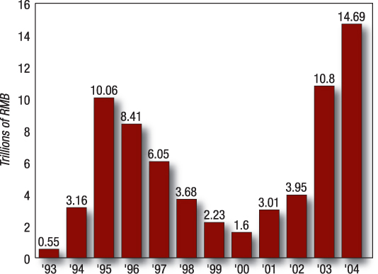

*Note: The Renminbi, often abbreviated as RMB, is the official currency of the People's Republic of China. The unit of Renminbi is a yuan.*

*Source: Futures Daily*

**China’s Futures Exchanges in 2004**

**Exchange Market Share by Notional Value**

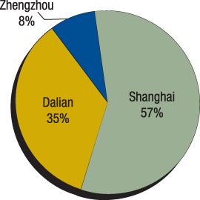

**Exchange Market Share by Contract Volume**

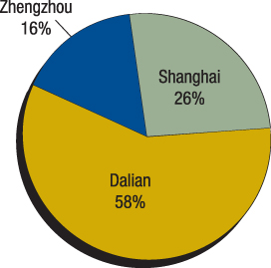

**Commodity Market Share by Notional Value**

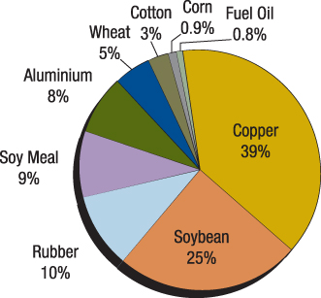

**Commodity Market Share by Contract Volume**

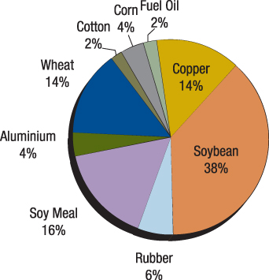

*Note: all volume figures for calendar year 2004.*

*Wang Xue Qin is vice general economist at the Zhengzhou Commodity Exchange and director of the options department. He has been working at the exchange since 1990 and has visited the U.S. on several occasions to study the workings of U.S. derivatives exchanges and options in particular.   
Nick Ronalds is senior vice president in the futures group of ABN Amro. He first visited China in 1989 while an official of the Chicago Mercantile Exchange to provide lectures and advice on the functioning of futures markets.*